~$500 Healthy Diet (For Obesity)
(Including Breakfast, Lunch and Dinner Plus Snacks)

- Oats 1.6Kg - Enough for 30 meals
  - Brought from Chuk Yuen Market
  - Approximately $20 per 800gram
  - Price: $40

- Chicken Chops (Large) 21 Pieces – Enough for 30 meals
  - Brought from market
  - Approximately ~ $11 per Piece
  - Price: $231
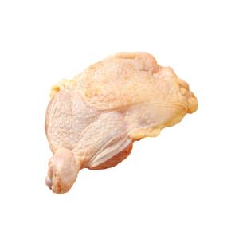

- Vegetables 5kg - Enough for 30 meals
  - Brought from market
  - Approximate $12 per kg
  - Price $60

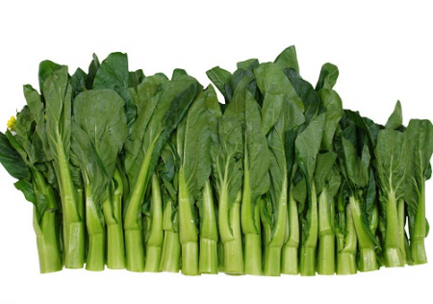

- Best Mart 360 Premium Thai Fragrant Rice 5kg – Enough for 30 meals
  - Brought from Best Mart 360
  - Approximately ~ $49 per packet
  - Price: $49
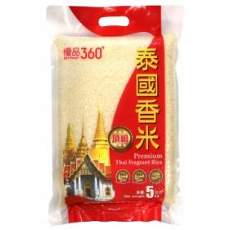

- Devondale Milk 7 large boxes 1 Liter - Enough for 60 snacks
  - Brought from ParknShop supermarket
  - Price $139.3

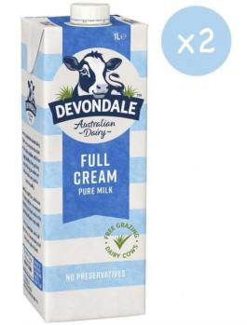

Total Price: Approximate $519.3 (All in terms of Hong Kong Dollars)
Updated: 16th April 2025 price subject to change

Ingredients And Menus (Total 90 Meals Plus Snacks)
3 Meals Per Day (Breakfast, Luch and Dinner Plus Snacks) for 30 days

These ingredients are based on portions. In case you don’t how to accurately divide it into portion. You can use a balance to weight the net weight of the ingredients and then divide it into portions base on the net weight.

- Breakfast meal – (30 meals) (Served for Breakfast)

  - Sweet Oat meal (8 spoonfull of dried Oats, equilvanent to 40 grams, little bit of sugar).

- Morning Snack 10:00 AM – (30 meals~ 125gram) (Served for Morning Snack 10:00AM)

  - After night Yogurt with sugar.

- Luch meal– (30 meals) (Served for Lunch)

- Chicken 2.8 onces (80 grams)
- Vegetables not less than 2/3 Bowl (~ 80gram).
- Rice 1 2/5 (one and two fifth fractional) Bowl (~ 120 - 150 gram).

- Afternoon Snack 16:00 PM – (30 meals ~ 125gram) (Served for Afternoon Snack 16:00PM)

  - After night Yogurt with sugar.

- Dinner – (30 meals) (Served for Dinner)

  - Chicken 2.8 onces (80 grams)
  - Vegetables not less than 2/3 Bowl (~ 80gram).
  - Rice 1 2/5 (one and two fifth fractional) Bowl (~ 120 - 150 gram).

- Everyday
  - Only allow 3 tea spoon of oil.
  - One Bowl equals 300 milligrams (300 grams).

